**Chapter 4**

Design

**4.1 Entity Relationship Diagram**

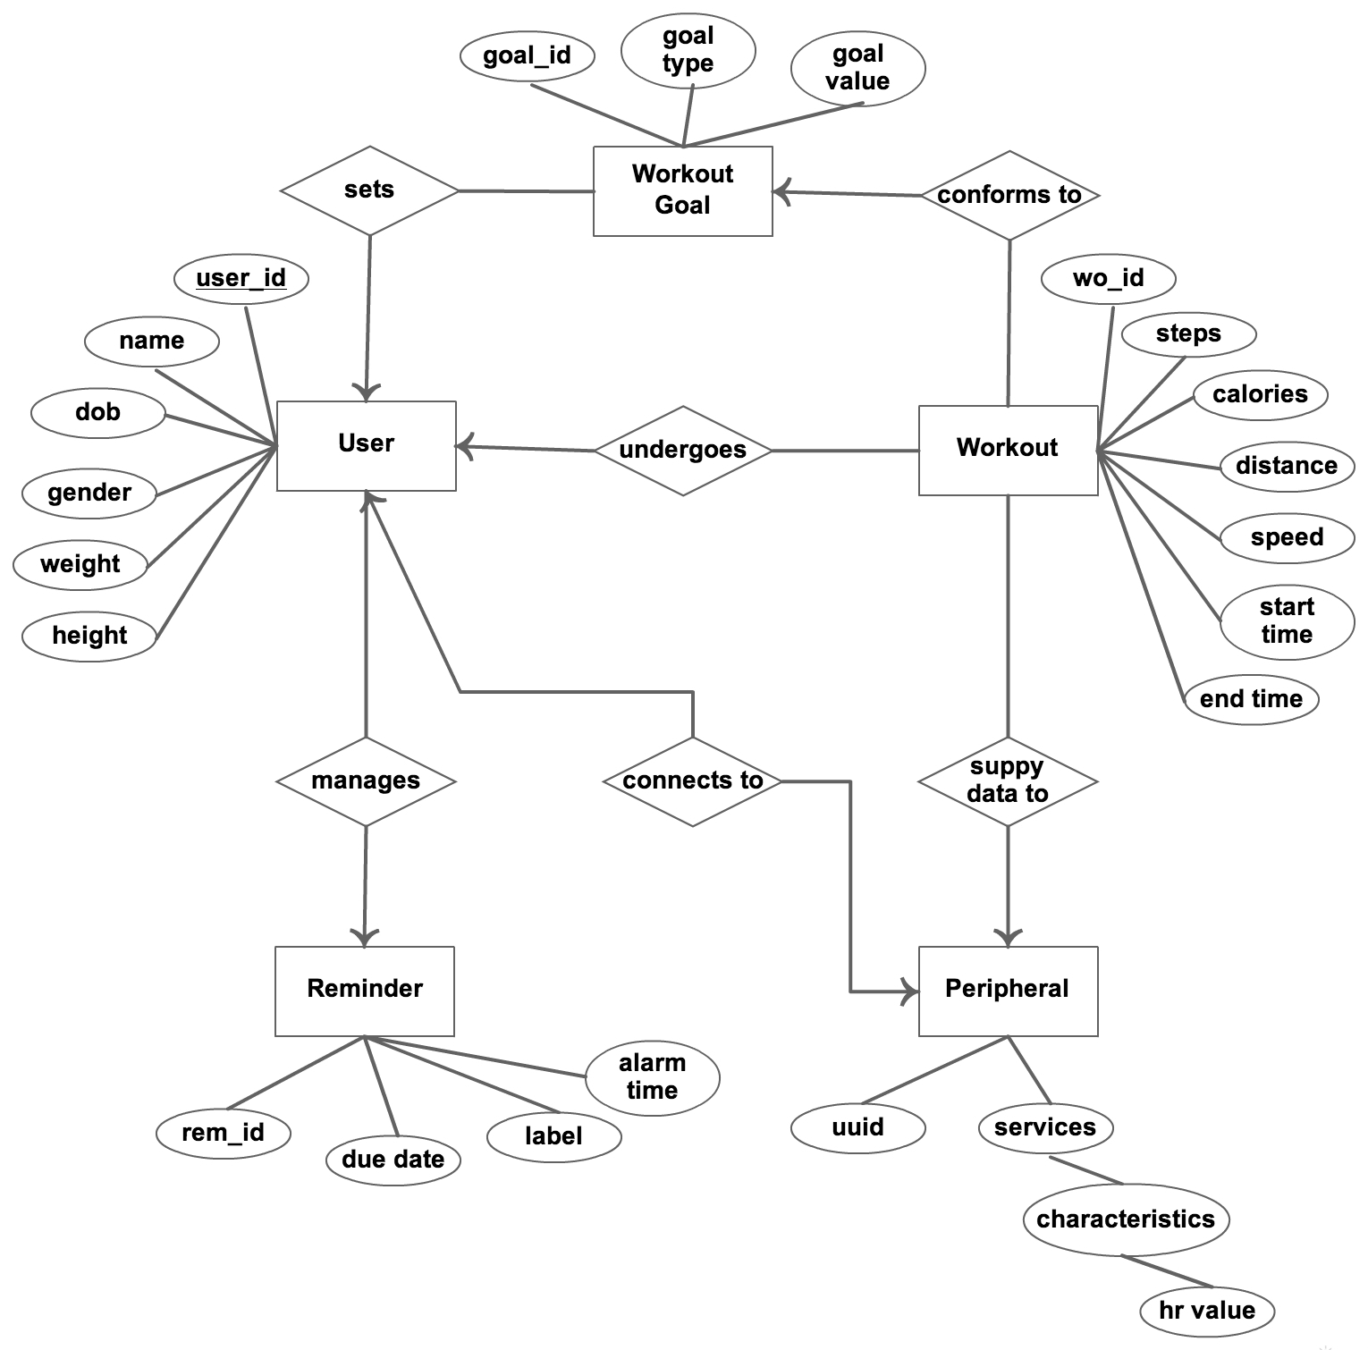

Figure 4.1 : ER Diagram

* 1. **Data Dictionary**

1. **TrackedObjectDetails2D** - This table contains all the important information of 2D objects.

Table 4.1 : TrackedObjectDetails2D

| Column Name | Data Type | Nullable | Default | Description |
| --- | --- | --- | --- | --- |
| audioFilePath | String | Y |  | Path of Audio File of particular object. |
| detailDescription | String | Y |  | Object detail description. |
| referenceURL | String | Y |  | URL of object. |
| Title | String |  |  | Title of the object. |
| videoFilePath | String | Y |  | Path of Video File of particular object. |

1. **TrackedObjectsDetails3D** - This table contains all the important information of 3D objects.

Table 4.2 : TrackedObjecstDetails3D

| Column Name | Data Type | Nullable | Default | Description |
| --- | --- | --- | --- | --- |
| audioFilePath | String | Y |  | Path of Audio File of particular object. |
| detailDescription | String | Y |  | Object detail description. |
| referenceURL | String | Y |  | URL of object. |
| Title | String |  |  | Title of the object. |
| videoFilePath | String | Y |  | Path of Video File of particular object. |

**4.3 Front-end Interface, validations and navigation Design**

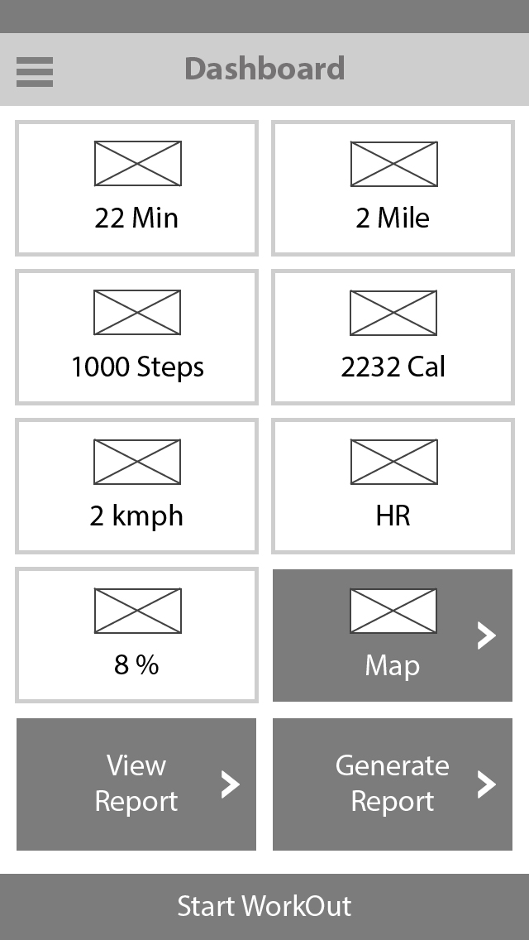

figure 1.1 : Dashboard

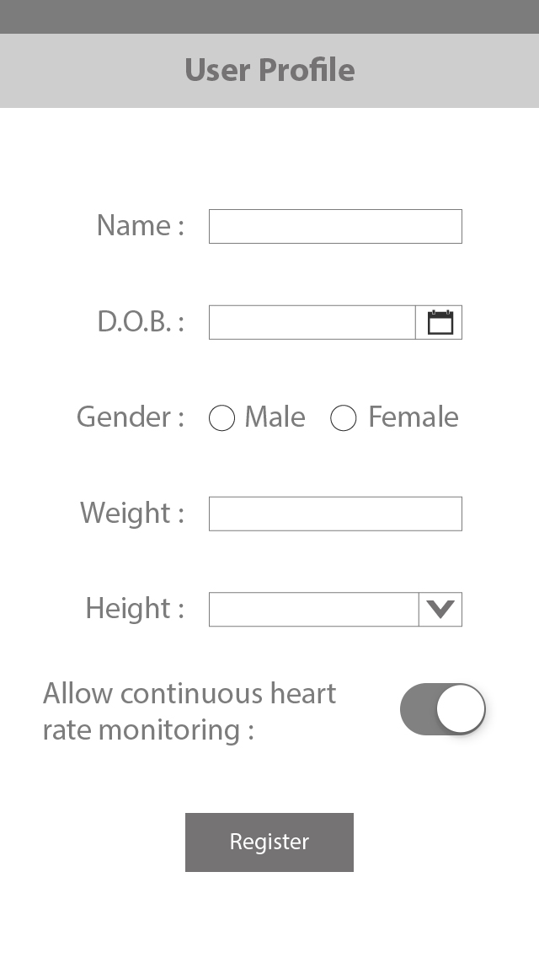

figure 1.1 : User Profile

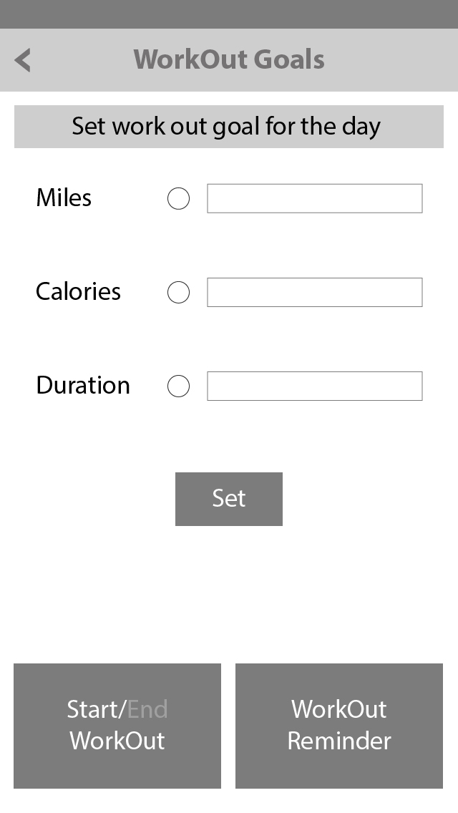

figure 1.1 : Workout Goals

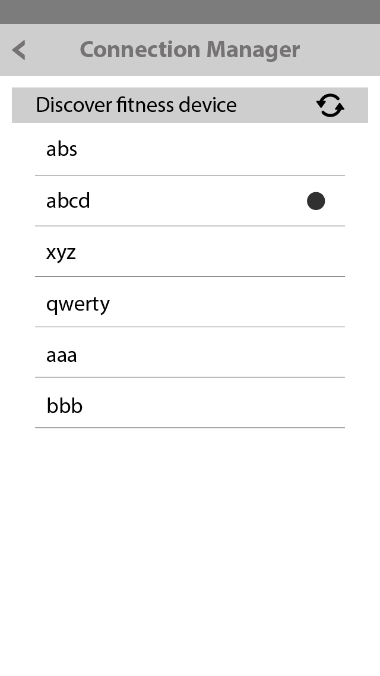

figure 1.1 : Connection Manager

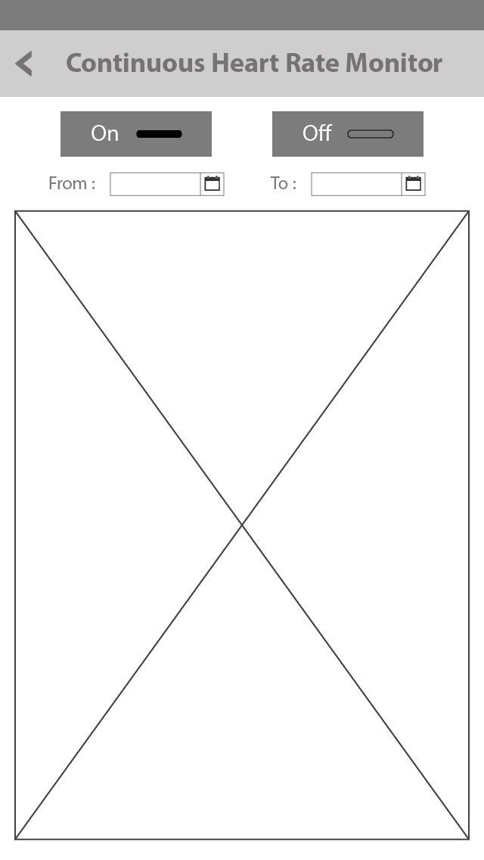

figure 1.1 : HR Monitor